June monthly report
โครงการ P2451496 งบยุทธ_CCU68_การต่อยอดและพัฒนาเทคโนโลยี Carbon capture and utilization (CCU) ที่มีความต้องการจากภาคอุตสาหกรรม และขับเคลื่อน National CCUS Alliance ร่วมกับเครือข่ายพันธมิตร
Sothearoth Heng
Under the supervision of
Dr. Pongkarn Chakthranont
ใบสั่งจ้างเลขที่ PO25005060
จ้างเหมาพัฒนางานจ้างพัฒนาการขยายขนาดเซลล์ไฟฟ้าเพื่อการผลิตแก๊สสังเคราะห์จาก CO₂ เชิงเคมีไฟฟ้า
งวดที่ 3: 1 June 2568 – 31 June 2568
……..........................................................
Dr. Pongkarn Chakthranont

- To-do list in June
- Screening of Bicarbonate electrolysis under a simulated flue gas with 3M KHCO3 electrolyte at different applied current densities
  - A typical bicarbonate electrolyzer
  - A BPM-integrated single-cell cyclic system
- Experimental Procedure
Synthesis of NiSAC by pyrolysis method
The synthesis of NiSAC catalyst was followed by our previous work. Initially, nickel phthalocyanine (NiPc), urea, and dicyanamide precursors were stoichiometrically weighed according to mass ratios of x:5:5, wherein urea and dicyanamide were maintained at 5 g each while varying the NiPc content (x = 0.25, 0.5, 1.0, and 2.0 g). Subsequently, the mixture was thoroughly mixed and ground until a homogeneous midnight blue powder was obtained. The fine powder was then transferred into a quartz boat covered with a capsule lid and subjected to polymerization at 800 °C (ramp rate = 10 °C·min⁻¹) in a horizontal tube furnace under an argon atmosphere (flow rate = 200 sccm) for 2 h. The as-prepared xNiSAC catalysts with different NiPc contents were finally obtained and labeled as 0.25NiSAC, 0.5NiSAC, 1.0NiSAC, and 2.0NiSAC.
Fabrication of IrO₂/TiPt felt anode electrode
The IrO₂/TiPt-felt anode electrode was prepared using a thermal deposition method involving multiple sequential steps. Initially, the TiPt felt (Purchased from ...) substrate was ultrasonically cleaned with deionized water and acetone to remove any surface contaminants. The cleaned substrate was subsequently etched in a 6M HCl solution at 90°C for 45 min to enhance surface roughness and adhesion properties. The dip-coating solution was prepared by dissolving 30 mg of IrCl₆·xH₂O in 10 mL of isopropanol (IPA) containing 10% v/v HCl. The etched TiPt felt substrate was then immersed in the dip-coating solution, followed by drying at 100°C for 5 min in an oven and subsequent calcination at 500°C for 10 min in a muffle furnace. After cooling to room temperature, the treated substrate was reweighed to determine mass gain. This dipping-drying-calcination cycle was repeated several times until the desired IrO₂ mass loading (1±0.2 mg/cm²) was achieved.

Preparation of NiSAC cathode electrode via spray coating method
The NiSAC gas-diffusion electrode was fabricated by spray coating onto Sigracet 39BB carbon paper or hydrophilic carbon cloth substrates. Typically, 150 mg of as-prepared NiSAC and 381 μL of XC-2 ionomer were ultrasonically dispersed in 10 mL of isopropanol (IPA) for at least 1 h to form a homogeneous dark colloidal suspension. The ink suspension was subsequently spray-coated onto a 6x6 cm² carbon substrate using an automated, custom-built spraying setup equipped with a syringe pump operating at a flow rate of 0.6 mL min⁻¹ on a hotplate maintained at 110°C, yielding a catalyst mass loading of 1.8 ± 0.1 mg.cm⁻².

Electrochemical measurements in bicarbonate electrolyzer
A 5 cm² MEA electrolyzer was used to evaluate the CO2RR performance under modulated operating conditions. The IrO₂-TiPt felt (3 x 3 cm), bipolar membrane (BPM, 4 x 4 cm), and 0.5NiSAC (2.5 x 2.5 cm) were employed as the anode, membrane, and cathode electrode, respectively. The MEA was assembled and tightened with a torque force of 30 inch-lbs. 3M KHCO₃ and 1M KOH electrolytes were recirculated and used throughout the experiment as the catholyte and anolyte, respectively. The humidified simulated flue gas (15%CO₂, 5%O₂, and 85%N₂) was introduced into 3M KHCO₃ electrolyte with a flow rate of 10 ml/min.

- Results
Influence of applied current density on bicarbonate electrolysis performance
In our previous studies on CO₂ electrolysis using a simulated flue gas composition of 15% CO₂, 5% O₂, and 85% N₂, the overall cell performance exhibited a significant loss in Faradaic efficiency (FE) due to the thermodynamic favorability of the oxygen reduction reaction (ORR) over the CO₂ reduction reaction (CO2RR). This competitive reaction pathway poses a critical challenge to achieving high selectivity for CO2RR in oxygen-containing environments, such as industrial flue gas streams.

To address this limitation, we developed a liquid bicarbonate electrolyzer, which demonstrates exceptional O₂ tolerance, effectively mitigating the ORR. The low solubility of oxygen in the bicarbonate solution significantly suppresses the ORR, enabling selective CO2RR. As illustrated in Figure 1, the bicarbonate electrolyzer achieves a total FE of 100% across a wide range of applied current densities, indicating negligible interference from the ORR. This high selectivity underscores the robustness of the bicarbonate-based system for CO2RR under oxygen-rich conditions. Furthermore, the system allows the CO/H₂ ratio tunability by adjusting the applied current density, offering flexibility for tailoring product distributions to specific applications. The overall system also exhibits remarkable stability, maintaining consistent performance at a current density of 100 mA/cm² over a 24-hour operational period.
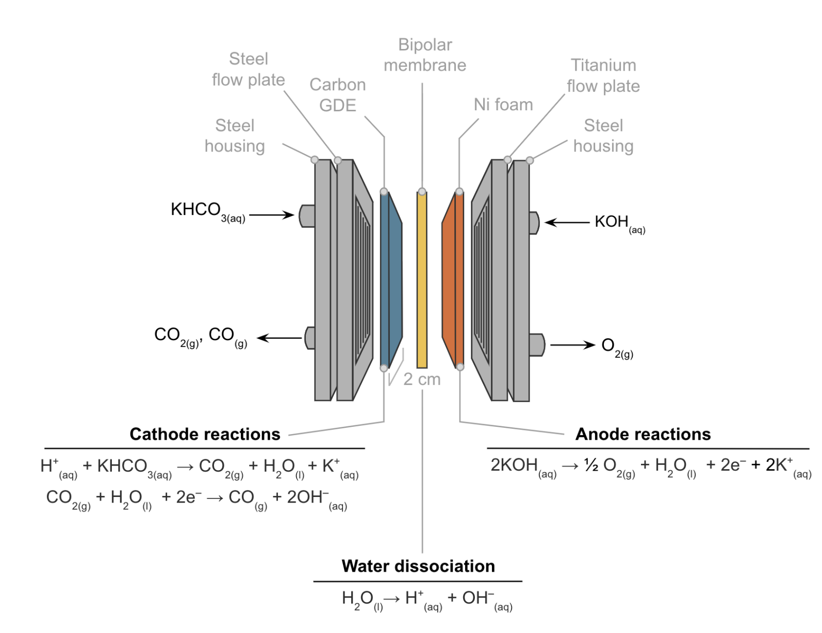
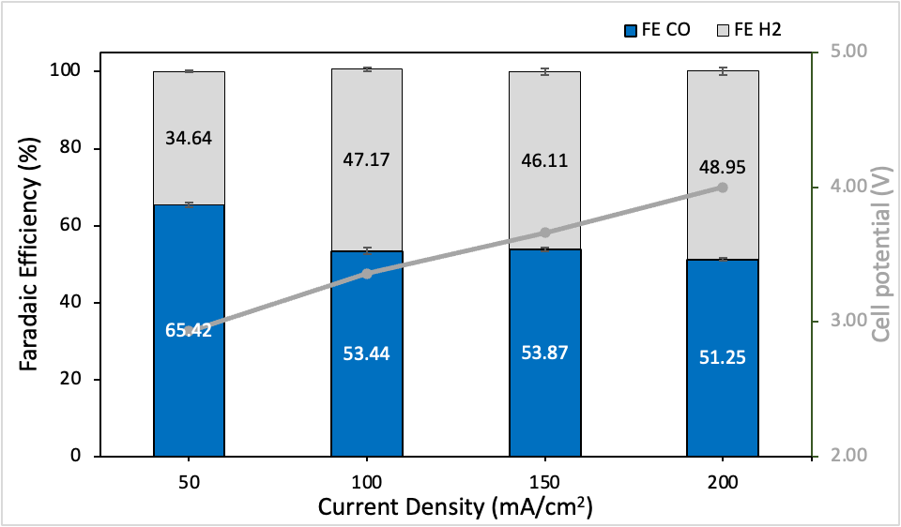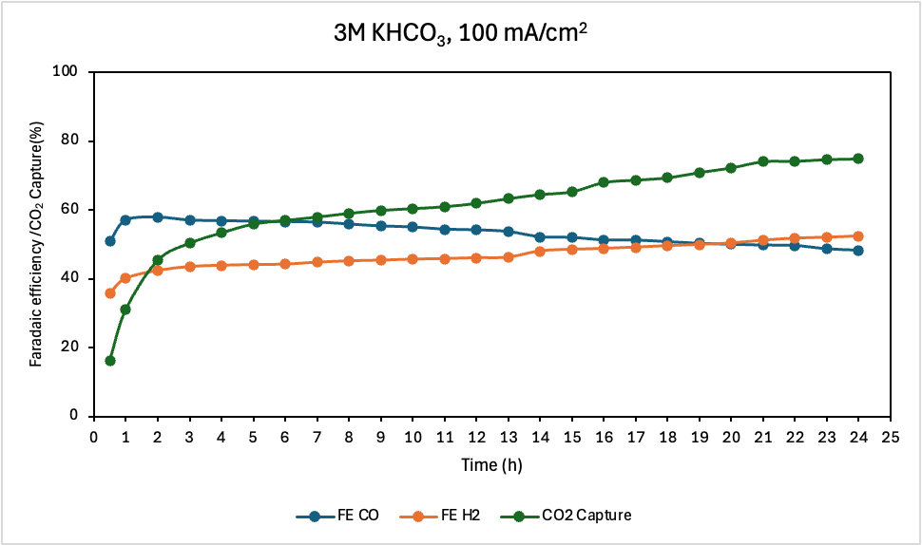
Figure 1. Bicarbonate electrolysis under 10ml/min of SFG in 20ml/min of 3M KHCO₃ with 1M KOH anolyte at current density range of 50 – 200 mA/cm²

To further enhance the efficiency of CO₂ reduction under oxygen-containing conditions, a bipolar membrane (BPM)-integrated single-cell cyclic system was developed and evaluated under operating conditions analogous to those of the previously described liquid bicarbonate electrolyzer. In this configuration, a simulated flue gas (SFG)-containing KHCO₃ electrolyte is introduced at the anode, where hydroxide (OH⁻) ions generated from water dissociation in BPM chemically react with CO₂ to produce bicarbonate (HCO₃⁻). The resulting bicarbonate ions are subsequently utilized for the CO₂ reduction reaction (CO2RR) at the cathode.

As depicted in Figure 2, the BPM-integrated cyclic system effectively suppresses the competitive oxygen reduction reaction (ORR), achieving tunable CO/H₂ product ratios and high carbon capture efficiency across a current density range of 50–300 mA/cm². These results demonstrate the system’s capability to maintain high selectivity for CO2RR in oxygen-rich environments. However, compared to the direct liquid bicarbonate electrolyzer, the cyclic system exhibits a slightly elevated cell voltage, indicating a trade-off between enhanced selectivity and energy efficiency. These findings highlight the potential of the BPM-integrated cyclic system with opportunities for further optimization to minimize energy requirements.

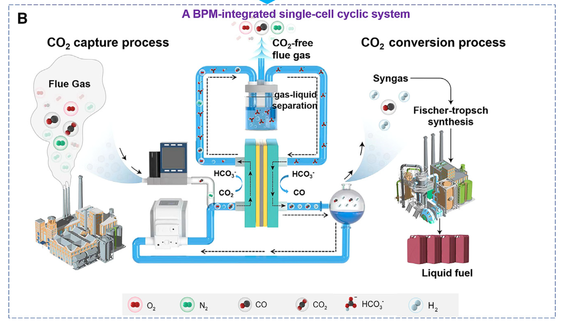
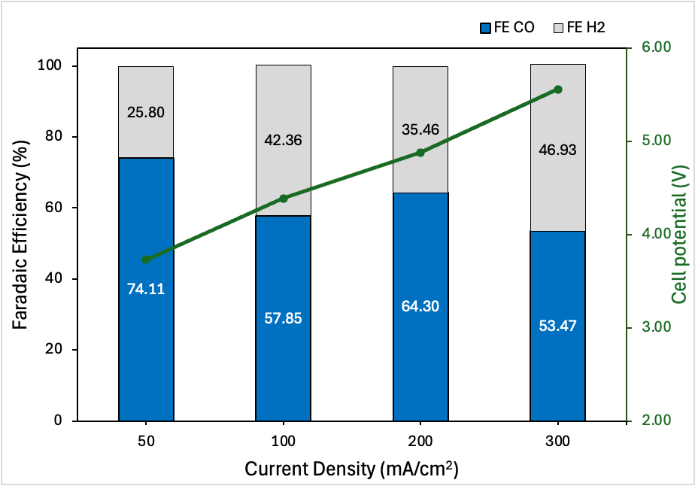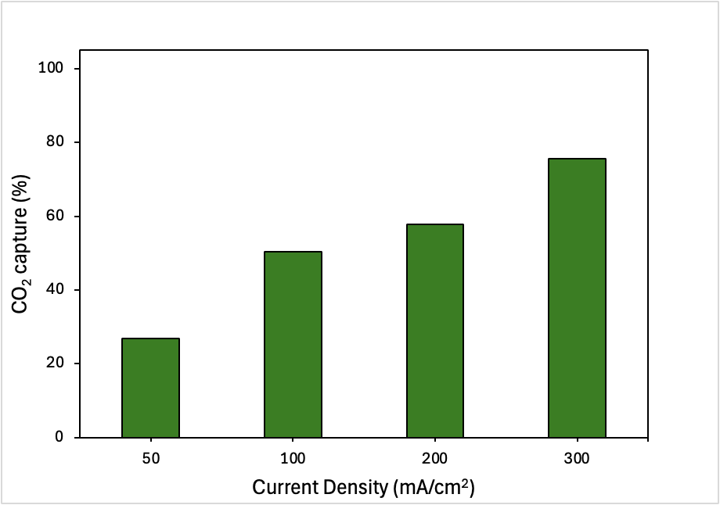
Figure 2. Bicarbonate electrolysis under 10ml/min of SFG and 50ml/min of 3M KHCO₃ at current density range of 50 – 300mA/cm²

- Upcoming tasks
- 100cm² electrolyzer – CO₂ electrolysis of 0.5Ni-SAC under a pure CO₂ at 100mA/cm²
- Catalyst screening for bicarbonate electrolysis with 3M KHCO₃ across a current density range of 50 – 300 mA/cm²

